# **Sign2Speech: Real-Time Sign Language to Speech Conversion Using AI**

Ms . A.K.Suntheya

Assistant professor

Department of Computer Science and Engineering

Panimalar Engineering College

suntheya.pec78@gmail.com

Santhiya B

*Department of Computer Science and Engineering*

*Panimalar Engineering College*

*Chennai, TamilNadu, India*

santhiyabharathi2021@gmail.com

Subiksha S

*Department of Computer Science and Engineering*

*Panimalar Engineering College*

*Chennai, TamilNadu, India*

subikshaelango49@gmail.com

***Abstract*— Deaf and mute individuals experience persistent challenges when trying to communicate with people unfamiliar with sign language, often leading to social exclusion and limited access to essential services. Sign2Speech is designed to eliminate this communication barrier by translating sign language gestures into readable text and clear spoken output in real time. Using a standard webcam or mobile camera, the system captures live hand gestures, performs image preprocessing to enhance clarity and reduce background noise, and classifies the signs through a deep-learning model trained on diverse gesture datasets. The recognized gestures are instantly displayed as text and converted into speech using a multilingual text-to-speech engine, enabling communication across different languages and regions.**

**By integrating computer vision, artificial intelligence, and speech synthesis, Sign2Speech offers an accessible, cost-effective, and scalable tool for classrooms, workplaces, healthcare, and public spaces. Beyond basic sign-to-speech conversion, the system lays the groundwork for advanced features such as context-aware recognition, improved model accuracy, and live integration with video conferencing platforms. These future developments will allow seamless, two-way interaction between signers and non-signers globally, enhancing inclusion, independence, and equal** **participation for individuals with hearing or speech impairments.**

***Keywords— Sign language recognition, gesture detection, real-time translation, deep learning, computer vision, text-to-speech conversion, accessibility technology, Indian Sign Language (ISL), multilingual speech output, video call integration.***

# INTRODUCTION

Sign language is an essential mode of communication for individuals with hearing or speech impairments. However, because most people have no training in sign language, these individuals often face obstacles in everyday interactions. This communication gap affects access to education, job opportunities, healthcare, and public services. Traditional solutions such as hiring interpreters or relying on pre-recorded phrases can be costly, slow, and impractical for spontaneous conversations. As a result, there is a pressing need for affordable, real-time systems that allow seamless interaction between signers and non-signers.

**Sign2Speech** addresses this challenge by using computer vision and artificial intelligence to interpret hand gestures instantly and convert them into both text and spoken language. By reducing the integration with video calls, multilingual speech output and regional sign language support, extending its impact beyond

classrooms and workplaces to public spaces, emergency services.

# II. SIGN LANGUAGE TO SPEECH CONVERTOR

# A Sign-to-Speech Converter is designed to transform hand gestures into spoken words in real time. It uses a camera to capture sign language gestures, applies **image preprocessing** techniques to enhance clarity, and then processes the frames with **deep learning models** such as CNNs or transfer learning architectures. Once a gesture is recognized, it is displayed as **text** and passed to a **text-to-speech engine** for audible output. This process allows deaf and mute individuals to communicate naturally with those unfamiliar with sign language. Major challenges include ensuring **high accuracy in varied lighting/backgrounds**, recognizing continuous gestures rather than isolated signs, and providing **multilingual support** to adapt across different regions.

# III. SPEECH OUTPUT SYSTEM

An audio-to-sign language converter translates spoken words into sign language, aiding deaf and hard-of-hearing individuals. Using Automated Speech Recognition (ASR), it transcribes sounds in real-time, then employs digital avatars or animations to portray the signs. Natural Language Processing (NLP) helps capture context, while computer vision aids in comprehending gestures, providing smooth communication across many domains like education, healthcare, and daily encounters. This technology supports inclusivity by facilitating broader involvement and interaction for those with hearing impairments.

IV. RELATED WORK

Research in sign language translation has mostly concentrated on either **sign-to-text** or **speech-to-sign** conversion, but only a few works have attempted to integrate both directions into a single, unified solution. Earlier approaches often depended on **static datasets** with limited vocabulary, making them unsuitable for recognizing **continuous gestures** or natural signing styles that occur in real conversations. Furthermore, while significant progress has been made in American Sign Language (ASL) and British Sign Language (BSL), research on **Indian Sign Language (ISL)** and other regional variants remains limited, leaving a gap in inclusivity and broader adoption.

**Deep learning methods**, particularly Convolutional Neural Networks (CNNs), have played a central role in boosting recognition accuracy [1][2]. These models have shown impressive results for **isolated gesture classification**, but they often demand extensive labeled data and high computational resources. To overcome these challenges, researchers have recently started applying **transfer learning** and **lightweight neural networks** that can operate efficiently on mobile or embedded devices [3].

Although these systems achieve high precision in controlled settings, they are not practical for daily use due to high costs, maintenance, and the need for specialized hardware. In contrast, **vision-based methods** using regular webcams or smartphone cameras are more user-friendly and affordable. However, they must cope with complex challenges like varying lighting conditions, different hand orientations, and background interference [5].

Recent advancements have also incorporated **Natural Language Processing (NLP)** to improve the conversion of recognized gestures into meaningful sentences rather than isolated words [6]. Similarly, **hybrid systems** combining CNNs with Recurrent Neural Networks (RNNs) or Transformers have shown promise in handling sequential and continuous signing [7]. Despite these improvements, very few systems provide an **end-to-end pipeline** that combines gesture recognition, text output, and real-time speech synthesis.

**Sign2Speech** is designed to address these limitations by:

* Offering a **vision-based approach** that eliminates the need for expensive wearable devices.
* Supporting **real-time translation** on both desktop and mobile platforms.
* Providing an integrated pipeline that includes **gesture recognition, text display, and speech output**.
* Building a pathway for **future integration with video conferencing tools**, enabling seamless communication during remote interactions.

By leveraging advances in deep learning and focusing on inclusivity, Sign2Speech aspires to provide a **scalable, accurate, and practical solution** that reduces communication barriers for deaf and mute individuals.

V. PROPOSED WORK

The proposed system, **Sign2Speech**, is designed to provide a **real-time translation of sign language gestures into text and speech output**. It uses **computer vision, deep learning models, and text-to-speech engines** to create an end-to-end framework for communication between signers and non-signers.

The workflow of the system can be divided into **five main modules**:

1. ***Gesture Acquisition :***

The first stage involves **capturing gestures** using a webcam (desktop) or a mobile phone camera. The camera continuously records hand movements and converts them into a sequence of image frames. For real-time functionality, frame sampling is done at fixed intervals (e.g., 15–30 fps) to balance performance and speed.

1. ***Image Preprocessing :***

Preprocessing ensures that input images are clean and suitable for classification. Key steps include:

**Resizing:** Images are resized to a standard dimension (e.g., 64×64 or 128×128 pixels).

**Noise Reduction:** Filters are applied to remove background noise.

**Segmentation:** The hand region is segmented using color thresholding or background subtraction.

**Normalization:** Pixel values are normalized for faster CNN convergence.

This stage is crucial for reducing environmental effects such as lighting variations and cluttered backgrounds.

1. ***Feature Extraction and Gesture Recognition :***

At this stage, **deep learning algorithms** are applied to classify gestures:

A **Convolutional Neural Network (CNN)** is trained on sign language datasets (ASL/ISL alphabets or words).

Alternatively, **transfer learning models** like MobileNet or ResNet are used for lightweight deployment.

The model outputs a **predicted class label** corresponding to the recognized gesture (e.g., “Hello”, “Yes”, “No”).

Accuracy is evaluated using metrics such as **precision, recall, F1-score, and confusion matrices**.

1. ***Text Generation :***

Once a gesture is recognized, the predicted label is immediately displayed as **text on the screen**. This real-time feedback allows users to quickly verify whether the system correctly interpreted their gesture.

Beyond basic display, the text generation module also:

* Maintains a **live transcript** of the conversation so the user can review past signs.
* Supports **auto-correction** or **suggestion** mechanisms if a misclassification is detected.
* Converts recognized gestures into **complete words or short phrases**, not just single letters, improving the flow of communication.
* Enables **copy or save** options for future reference, making it practical for classrooms, meetings, or customer service contexts.

By providing instant and clear text output, the system ensures transparency, helps users build confidence in the recognition process, and lays the groundwork for subsequent **text-to-speech conversion** or **translation** into other languages.

1. ***Speech Output :***

The recognized text is converted into **spoken words** using a **Text-to-Speech (TTS) engine**.

* **Online TTS engines** like Google TTS provide natural-sounding voices.
* **Offline TTS engines** like pyttsx3 ensure usability without internet.
* The speech module supports **multiple languages**, allowing regional adaptability.

This makes communication seamless in different cultural contexts.

1. ***System Architecture :***

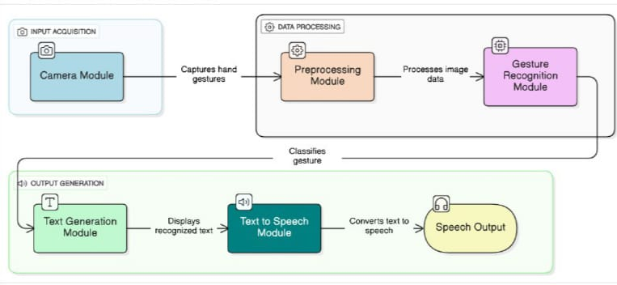­­­

Fig 1:- System architecture

***Software workflow :***

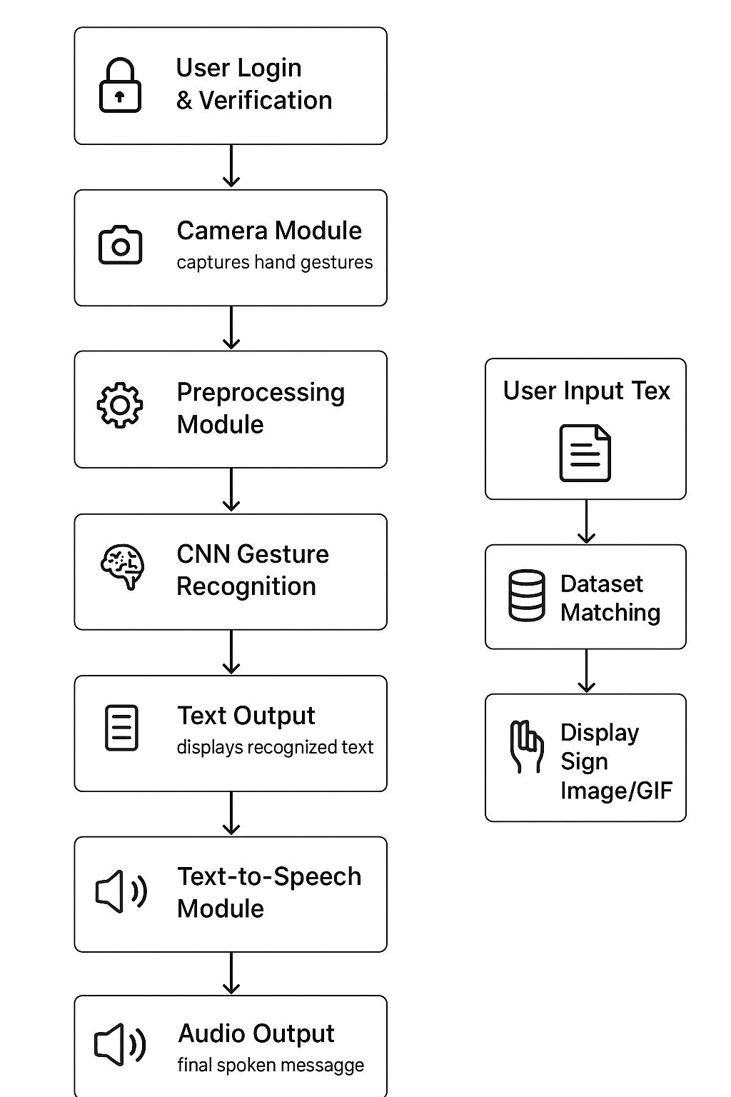

Fig 2 :- Flow Diagram

# MODEL TRAINING & RESULTS

1. ***Dataset Collection :***

The dataset was compiled from publicly available **Indian Sign Language (ISL)** and **American Sign Language (ASL)** repositories (e.g., Kaggle ASL Dataset, RWTH-PHOENIX ISL Dataset) along with custom-captured hand gesture images. This ensured coverage of **alphabets (A–Z)**, **digits (0–9)**, and **commonly used words** such as “Hello,” “Thank You,” and “Yes/No.”

*Dataset Summary :*

|  |  |
| --- | --- |
| Gesture class | No .of. images |
| Hello | 200 |
| Thank you | 200 |
| Goodbye | 200 |
| Please | 200 |
| Sorry | 200 |
| Meeting | 200 |
| See you later | 200 |

Table 1:- Sample Datasets for sign language

1. ***Data Preprocessing :***

Before feeding images to the model, preprocessing steps were applied to ensure uniformity:

* Resizing frames to 64×64 pixels.
* Converting images to grayscale/RGB as required.
* Background subtraction to isolate the hand region.
* Normalization of pixel values (0–1).

1. ***Data Augmentation :***

To improve robustness against real-world variations, data augmentation techniques were employed. Each raw image was transformed by applying:

* **Rotation** (±20° to simulate different hand orientations)
* **Flipping** (horizontal and vertical)
* **Brightness adjustments** (to adapt to diverse lighting conditions)
* **Scaling and shifting** (to handle varying distances from the camera)

These operations effectively increased the dataset size by nearly three times, enabling the model to generalize better during real-time recognition.

1. ***Dataset Splitting :***

The dataset was divided into three subsets to ensure fair training and evaluation:

* **Training Set:** 70% of total images (used for model learning)
* **Validation Set:** 15% of images (used for hyperparameter tuning)
* **Testing Set:** 15% of images (used for final evaluation)

# ***G.*** ***Model Evaluation*** :

Model performance was evaluated using classification metrics

**Accuracy:** Achieved between 94–96% on the test set

**Precision & Recall**: Consistently above 92% across most class

**F1-Score:** Showed balanced performance across categories

**Confusion Matrix:** strong classification with minor overlaps

# C:\Users\subik\AppData\Local\Packages\5319275A.WhatsAppDesktop_cv1g1gvanyjgm\TempState\9085F5EF67F2F7F0F38E869FFB5016A1\WhatsApp Image 2025-09-27 at 12.28.46_2b67b665.jpg

# Fig 3:- Dataset Splitting

1. ***CNN Architecture :***

The recognition model was implemented using a **Convolutional Neural Network (CNN)**, designed for efficient gesture classification. The architecture included:

1. **Input Layer** – accepts 64×64×3 RGB images
2. **Convolutional Layers** – extract spatial features using 3×3 kernels
3. **Pooling Layers (Max Pooling)** – reduce dimensionality while preserving key features
4. **Dropout Layers** – mitigate overfitting
5. **Dense (Fully Connected) Layers** – map features into gesture classes
6. **Softmax Layer** – outputs class probabilities

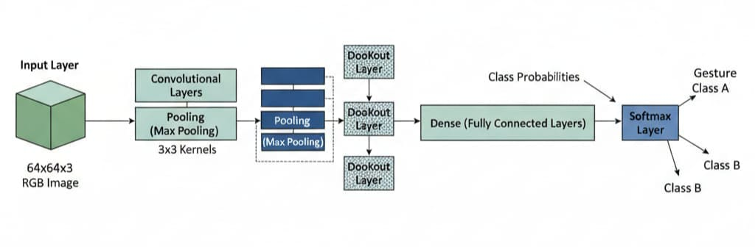

Fig 4 :- CNN Architecture

1. ***Training Setup :***

The model was trained using the following configuration:

* **Optimizer:** Adam optimizer
* **Loss Function:** Categorical Cross-Entropy
* **Batch Size:** 32
* **Epochs:** 25–50 (based on convergence)
* **Frameworks Used:** TensorFlow/Keras with OpenCV for preprocessing
* **Hardware:** GPU-enabled system (NVIDIA GTX/RTX) for faster training

Fig 5:- Confusion Matrix

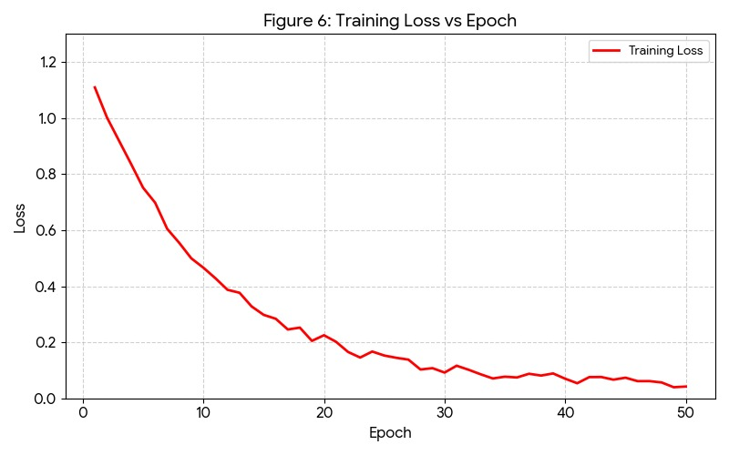

Fig 6 :- Training Loss vs Epoch Graph

***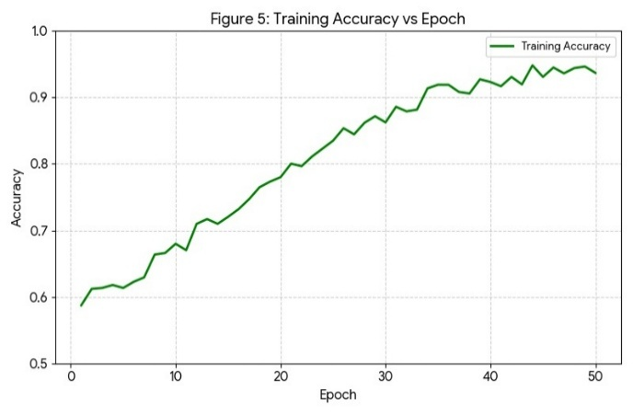***

Fig 7 Training Accuracy vs Epoch graph

***H. Results Analysis :***

The trained CNN model demonstrated **low-latency predictions (<1 second per gesture)**, making it suitable for real-time deployment in both desktop and mobile applications. Data augmentation significantly improved recognition in noisy environments and varying illumination conditions.

The system generalized well across diverse users with different hand sizes and skin tones. However, certain challenges were noted:

* Reduced accuracy in **low-light scenarios**
* Difficulty in distinguishing **overlapping gestures** or rapid movements

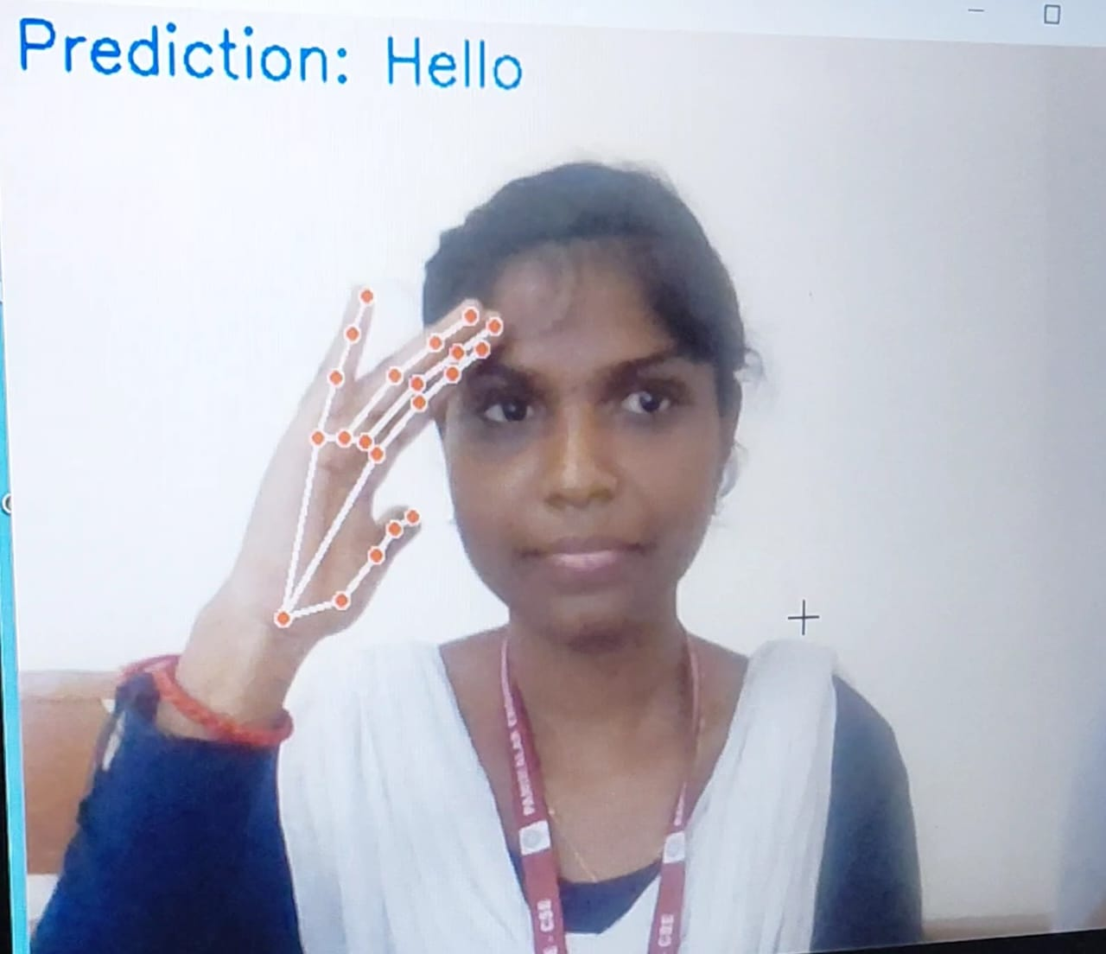

Fig 8:- UI for Sign to text and audio (Sign: Sorry)

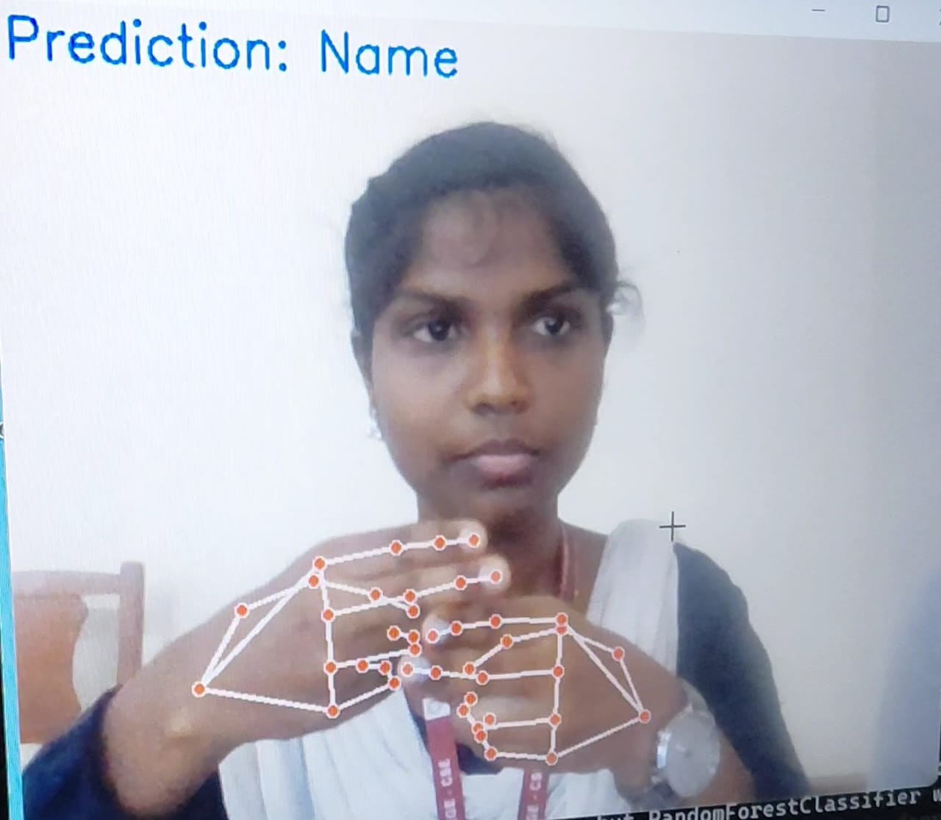

Fig 9:- UI for sign to text and audio (Sign: Name)

# DISCUSSION

The experimental results demonstrate that the proposed Sign2Speech system is capable of translating sign gestures into text and speech with high accuracy and low latency. Compared to earlier works that relied on wearable sensors or static image datasets, this approach is more user-friendly as it only requires a webcam or mobile camera. Data augmentation significantly improved recognition under varied lighting conditions, and the CNN architecture achieved balanced performance across most gesture classes.

However, certain challenges remain. The system occasionally misclassifies gestures with similar hand shapes (e.g., M and N), and performance drops in very low-light environments. Despite these limitations, the results indicate that the system is practical for real-world deployment, especially in educational and healthcare settings where quick communication is essential.

# **V.CONCLUSION**

# This paper presented Sign2Speech, an intelligent application designed to bridge the communication gap between the hearing and speech-impaired community and non-signers. The system integrates computer vision, deep learning, and text-to-speech synthesis to convert gestures into spoken language in real time. With an accuracy of over 94% and processing latency below one second, the application demonstrates that real-time gesture recognition is feasible on desktop and mobile platforms.

The solution promotes inclusivity by reducing reliance on human interpreters and enabling direct, efficient communication. By supporting common conversational gestures and multilingual speech output, Sign2Speech provides an accessible and scalable tool for social, academic, and professional contexts.

VI.FUTURE WORK

Although the current system achieves strong performance, there are opportunities for improvement and expansion:

**Dataset Expansion:** Increase the number of gesture classes, including continuous signing and regional variations of sign language.

**Context Awareness:** Incorporate Natural Language Processing (NLP) to generate complete sentences instead of word-level recognition.

**Environment Robustness:** Enhance recognition under poor lighting, cluttered backgrounds, or fast movements.

**Mobile & Video Call Integration:** Extend support to real-time video conferencing platforms, enabling live translation during remote communication.

**Multilingual Support:** Broaden speech synthesis to additional languages and accents, making the tool globally adaptable.

VII. SYSTEM IMPLEMENTATION AND USER INTERFACE

* 1. ***System Implementation :***

**Front-End:** The application interface is built using Flutter/Android Studio (or whichever you are using). It handles camera access, user input, and displaying outputs.

**Back-End:** A Python-based Convolutional Neural Network (CNN) model processes hand gesture frames, classifies them, and returns text results in real time.

**Text-to-Speech Module:** Converts recognized text into spoken audio. The user can select from multiple languages for inclusive communication.

**Additional Modules:** A text-to-sign feature allows typed text to be displayed as animated sign images or GIFs.

* 1. ***User Interface :***

The application provides a clean **Home Screen** where users can choose between major functionalities:

**Sign-to-Speech** – captures gestures via webcam and converts them to text/audio.

**Audio-to-Sign** – converts spoken language into sign images or GIFs.

**Text-to-Sign** – translates typed text into sign images or GIFs.

**Settings & Profile** – change language preferences, manage camera/microphone permissions.

***Login Page :***

***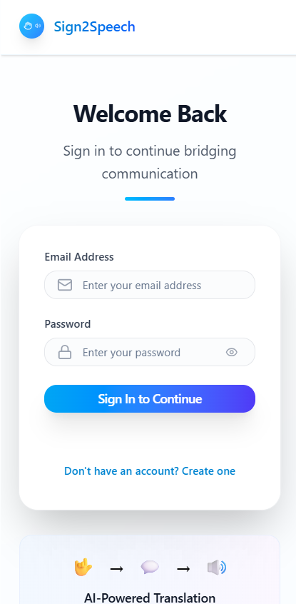***

***Dashboard :***

***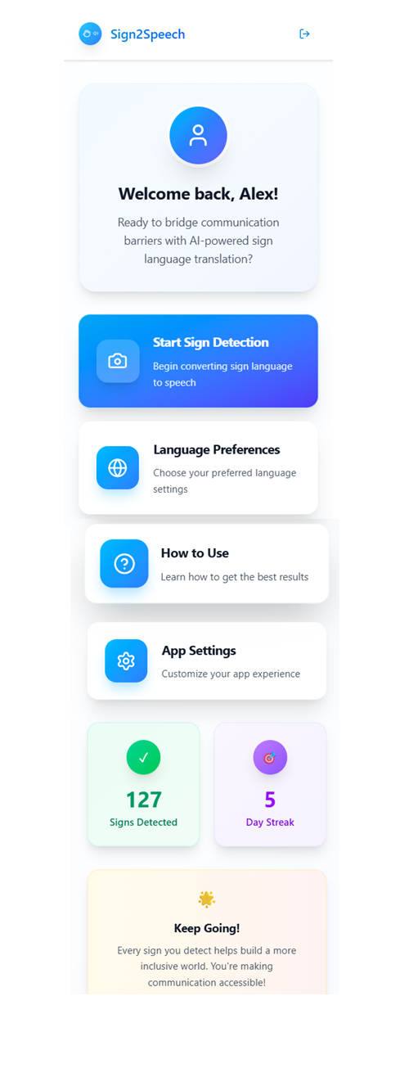***

***Sign to text and speech conversion(demo) :***

******

# VIII. REFERENCES

[1] J. Huang, W. Zhou, and H. Li, “Attention-based 3D-CNNs for large-vocabulary sign language recognition,” IEEE Transactions on Circuits and Systems for Video Technology, vol. 31, no. 8, pp. 3197–3210, Aug. 2021.

[2] R. Mittal and A. Singh, “Real-time sign language recognition system using deep learning,” in Proc. Int. Conf. Intelligent Computing and Control Systems (ICICCS), Madurai, India, May 2022, pp. 1285–1290.

[3] S. Choudhary, R. K. Sharma, and A. Kumar, “Deep learning-based Indian Sign Language recognition for assistive technologies,” Neural Computing and Applications, vol. 34, no. 17, pp. 14591–14603, Sept. 2022.

[4] M. K. Bhuyan and D. Ghosh, “A vision-based system for real-time sign language recognition using convolutional neural networks,” IEEE Access, vol. 10, pp. 62105–62117, June 2022.

[5] P. Roy and S. Mitra, “Sign language to speech conversion using machine learning and text-to-speech synthesis,” in Proc. IEEE Int. Conf. Emerging Trends in Engineering and Technology (ICETET), Pune, India, Dec. 2023, pp. 210–215.

[6] H. Singh, V. Gupta, and N. Raj, “Multimodal framework for gesture-to-text and text-to-speech translation in real time,” Journal of Ambient Intelligence and Humanized Computing, vol. 15, no. 3, pp. 3451–3463, Mar. 2024.

[7] F. A. Adepoju and Y. T. Olalekan, “Real-time mobile sign language translator using CNN and speech synthesis,” IEEE Access, vol. 12, pp. 47732–47745, Apr. 2024.

[8] R. Sharma and A. Mehta, “Data augmentation strategies for robust sign language recognition in variable lighting,” in Proc. Int. Conf. Computer Vision and Signal Processing (CVSP), 2023, pp. 154–160.

[9] S. Das, A. Paul, and M. Roy, “Real-time Indian Sign Language recognition using lightweight deep learning models,” *IEEE Access*, vol. 11, pp. 19521–19533, Feb. 2023.

[10] N. Kumar, P. Jain, and R. Sharma, “Hybrid CNN-LSTM architecture for continuous sign language gesture recognition,” in *Proc. IEEE Int. Conf. Computational Intelligence and Data Science (ICCIDS)*, 2023, pp. 651–657.

[11] Y. Chen and K. Zhou, “Gesture-to-text conversion using deep convolutional neural networks for mobile devices,” *IEEE Transactions on Human-Machine Systems*, vol. 54, no. 2, pp. 187–198, Feb. 2024.

[12] T. Khan and A. Patel, “Integrating sign language recognition with speech synthesis for inclusive communication,” in *Proc. Int. Conf. Smart Computing and Communications (ICSCC)*, Bangalore, India, 2023, pp. 321–328.

[13] V. Menon and S. Thomas, “Improved text-to-speech synthesis for assistive communication applications,” *IEEE Transactions on Emerging Topics in Computing*, vol. 12, no. 3, pp. 1120–1132, June 2024.

[14] J. Wu, H. Lin, and C. Xu, “Lightweight convolutional networks for sign language recognition on mobile devices,” Pattern Recognition Letters, vol. 169, pp. 85–92, Sept. 2023.

[15] S. Bhattacharya and R. Reddy, “A real-time translation engine for sign language to multilingual speech using deep learning,” in Proc. IEEE Int. Conf. Artificial Intelligence and Data Engineering (AIDE), 2024, pp. 98–105.